Linear voltage regulator:  
  
Variable voltage regulator:

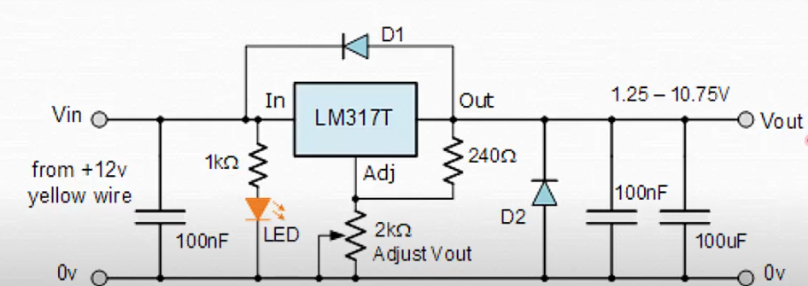

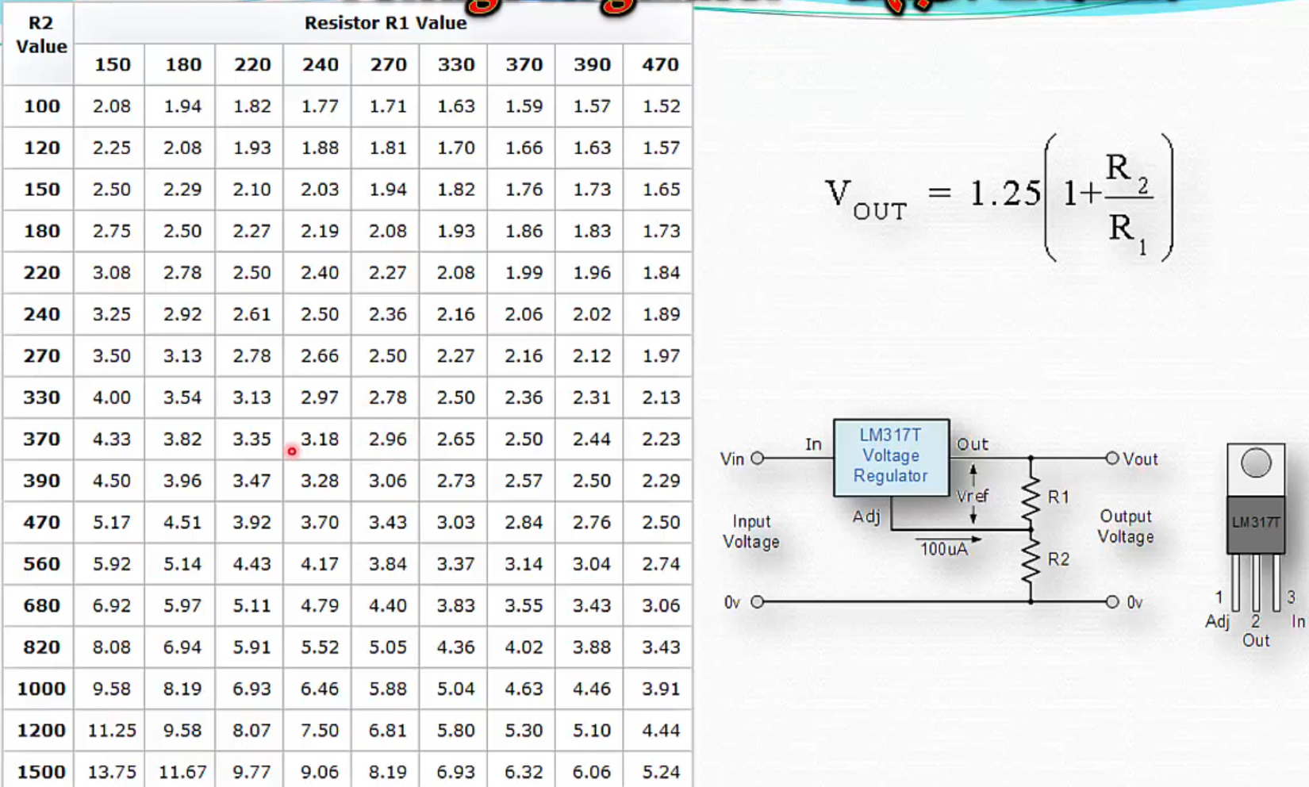

Bad way to increase the current:  
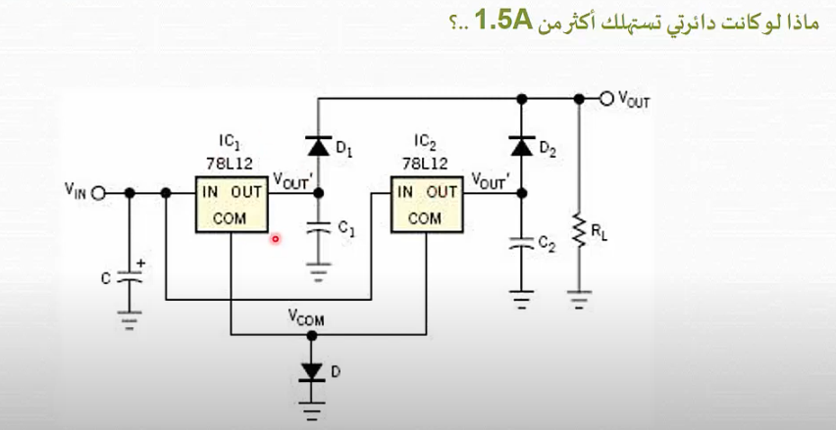

Good ways to increase the current:



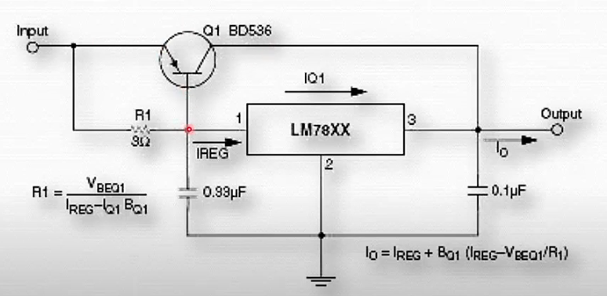

Must be **<**1**µF**

